**Jenkins Task**

**Task Description:**

Launch jenkins and explore creating projects and users.

Explanation:

1. In AWS, launch an EC2 instance.

Login to AWS console, In EC2 dashboard, click launch instance.

The following details is given.

Name : my-jenkins-server

AMI: Amazon Linux 2 AMI

Instance Type: t2.micro

Key Pair: New key pair is generated

Post launching instance, the security group can be modified by Adding a new rule to allow **Custom TCP (port 8080).**

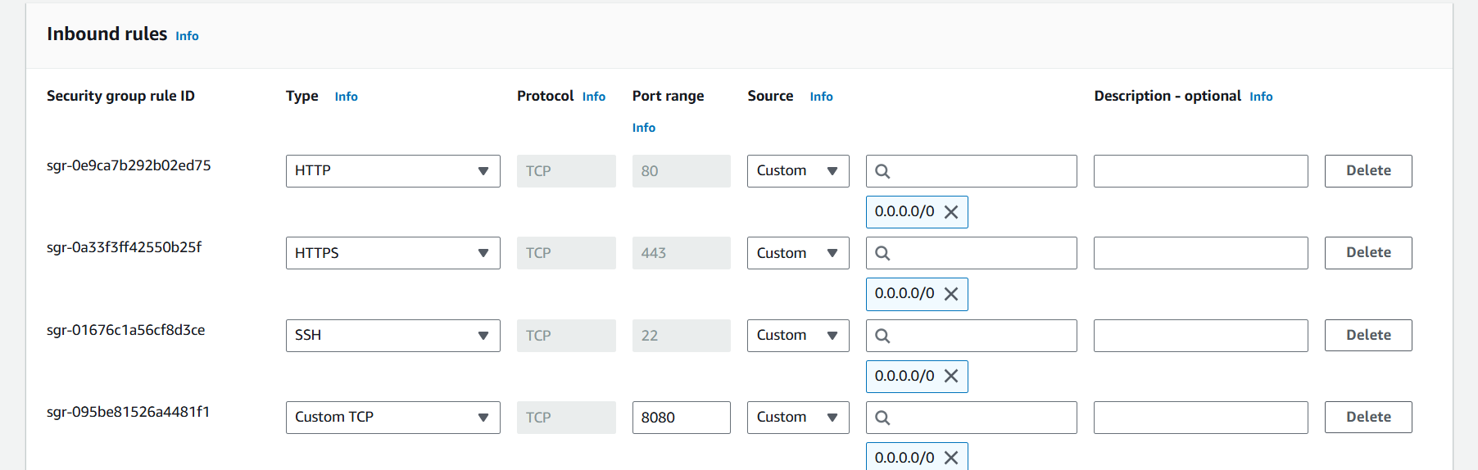

1. Connect to the instance

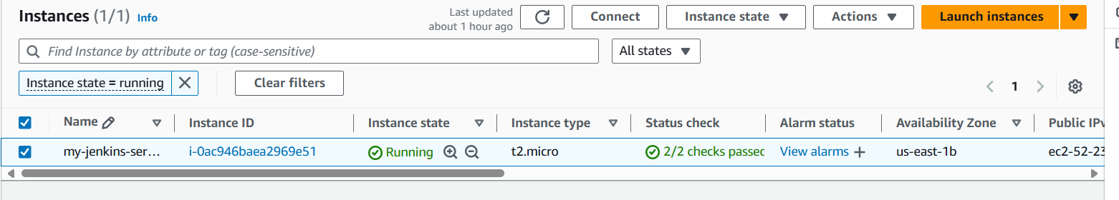

Choose connect using EC2 instance connect.

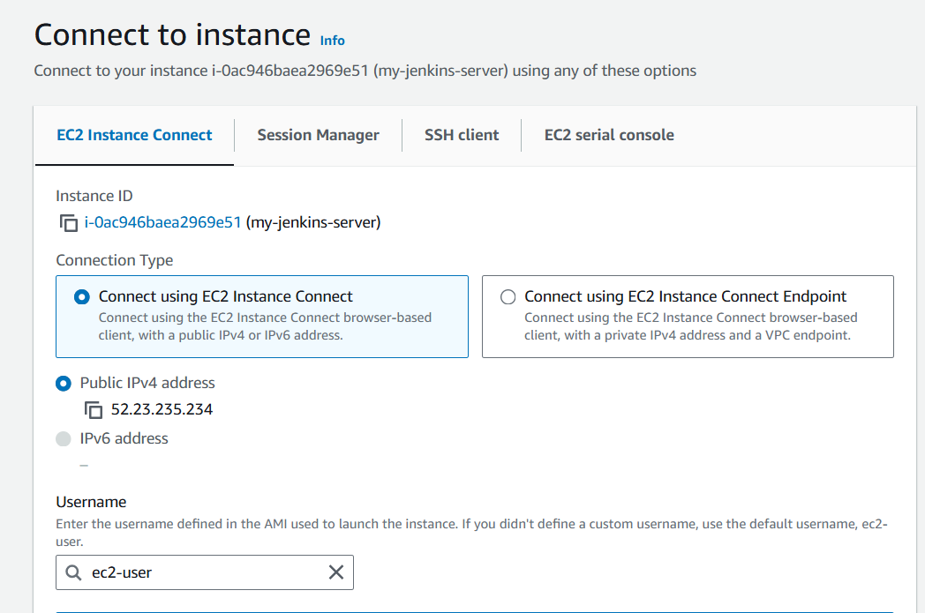

1. Install Jenkins on the EC2 Instance

For Software update : sudo yum update –y



Add the Jenkins repo : sudo wget -O /etc/yum.repos.d/jenkins.repo \

<https://pkg.jenkins.io/redhat-stable/jenkins.repo>

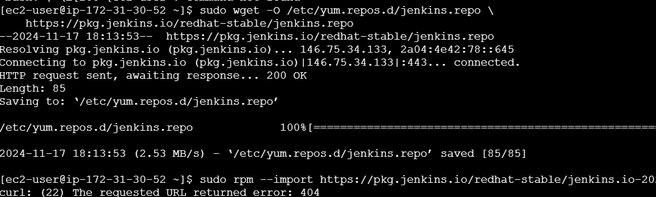

Import a key file from Jenkins-CI to enable installation from the package:

sudo rpm --import https://pkg.jenkins.io/redhat-stable/jenkins.io-2023.key

sudo yum upgrade



Install Java (Amazon Linux 2023): sudo dnf install java-17-amazon-corretto -y

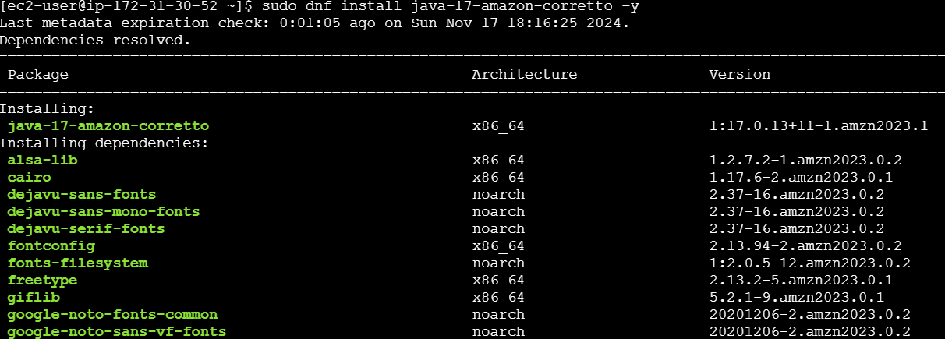

Install Jenkins: sudo yum install jenkins -y

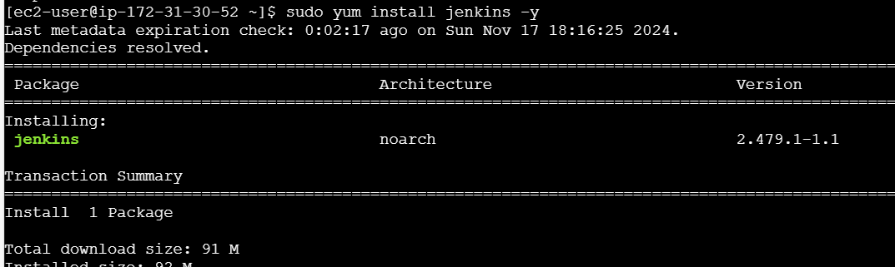

Enable the Jenkins service : sudo systemctl enable Jenkins

Start Jenkins : sudo systemctl start jenkins

Check status : sudo systemctl status jenkins

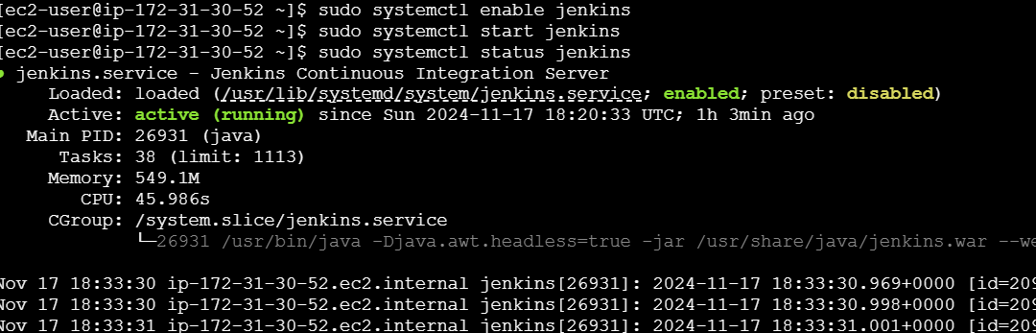

1. Access Jenkins from a Browser

In EC2 Dashboard, select the instance, and copy the Public IPv4 address.

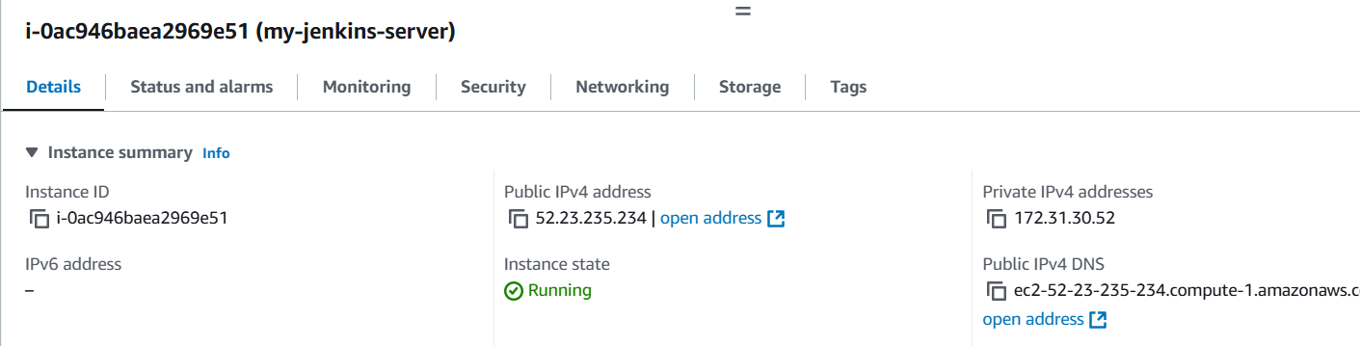

Access Jenkins: Open a browser and go to: <http://52.23.235.234:8080>.

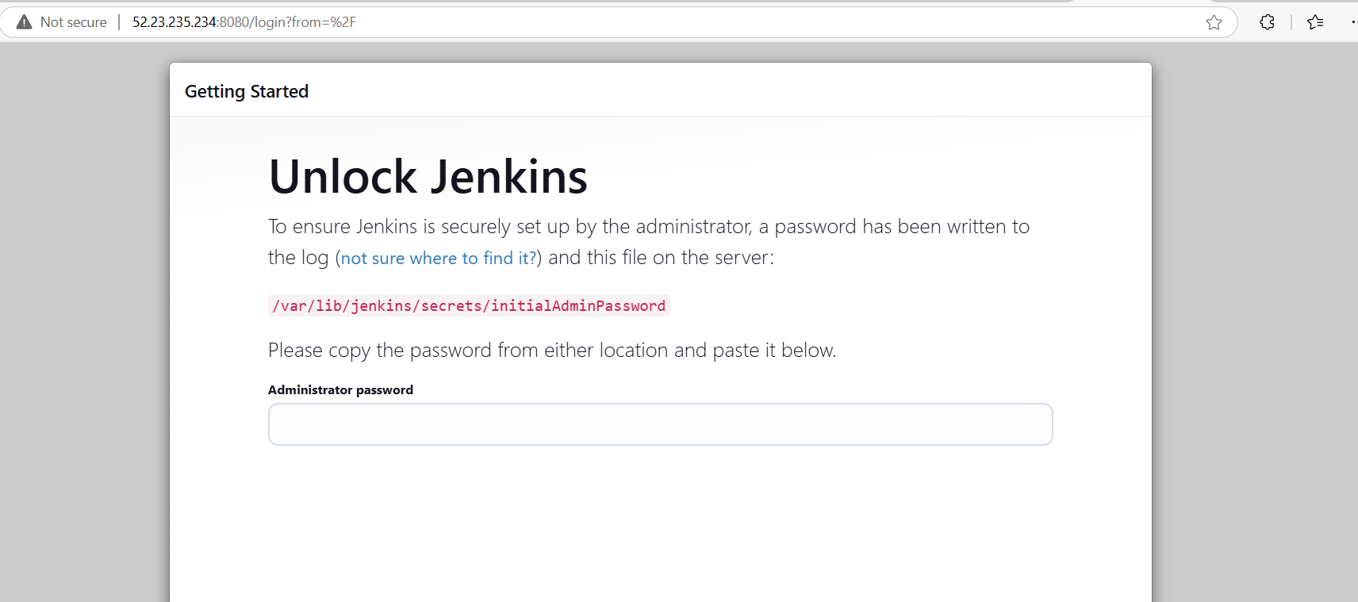

In the Jenkins webpage, to enter the password, use the command sudo cat /var/lib/jenkins/secrets/initialAdminPassword



Copy the displayed password and paste it in the webpage.

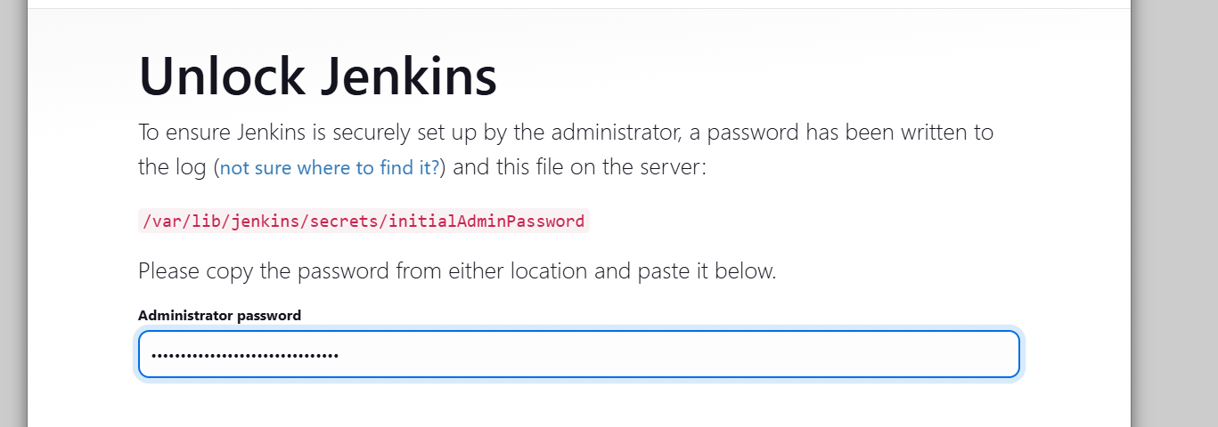

Install suggested Plugins.

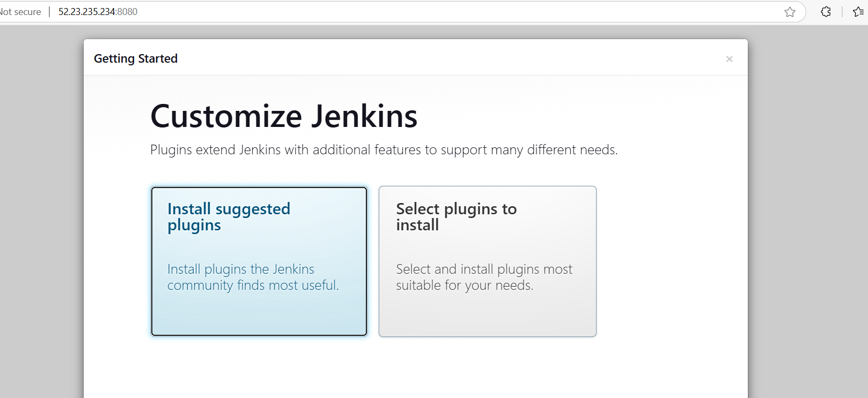

Create the first admin user, give all the credentials.

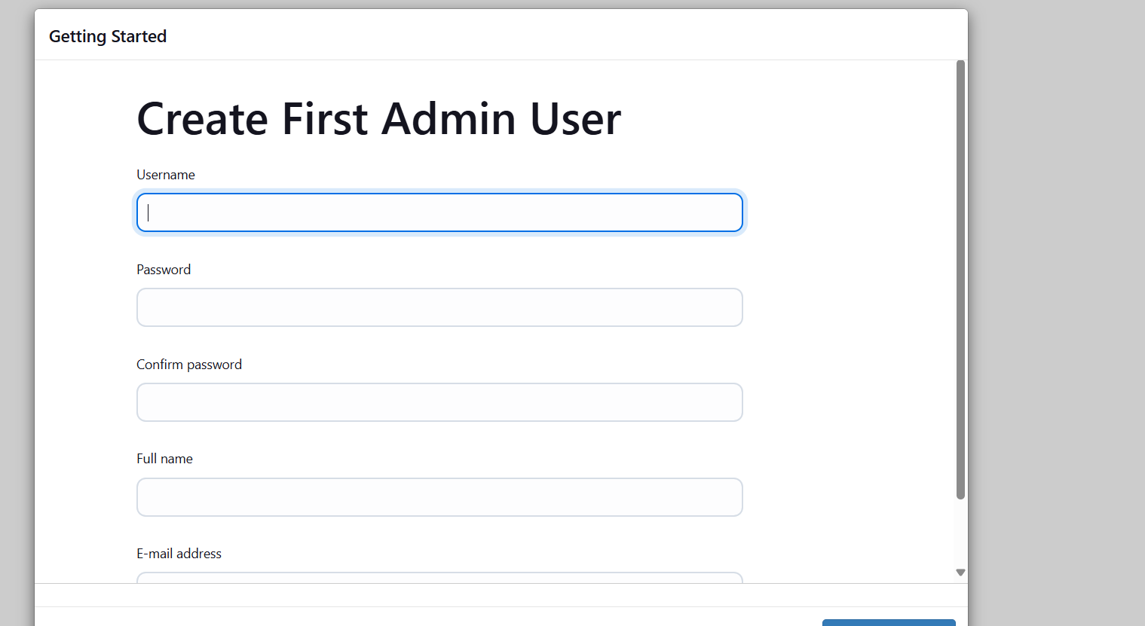

Save and continue.

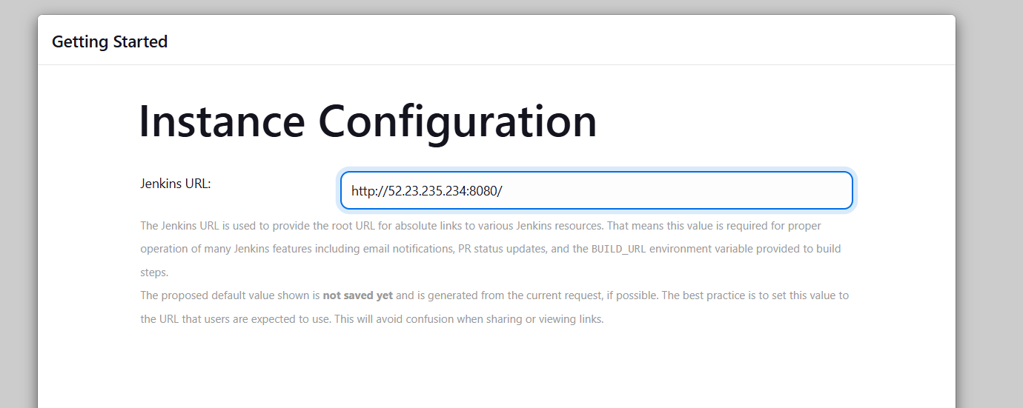

Click start using Jenkins.

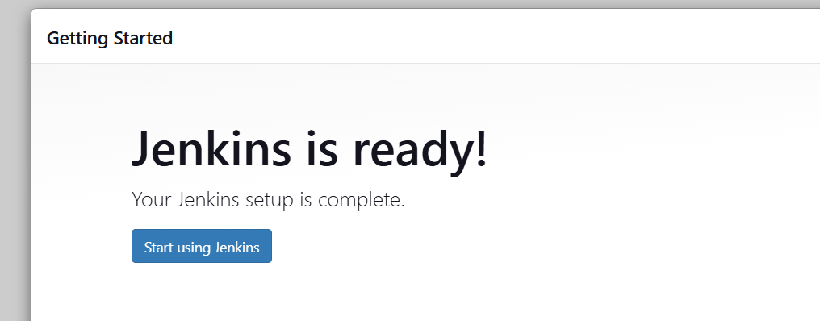

The following page is displayed.

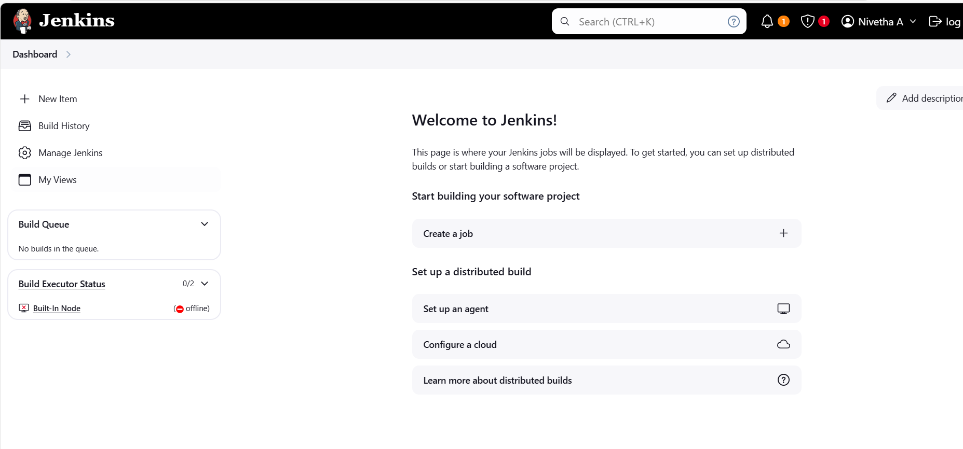

1. Creating Project in Jenkins

Click New Item on the Jenkins dashboard.

Project Name : My_Project

Choose freestyle project.

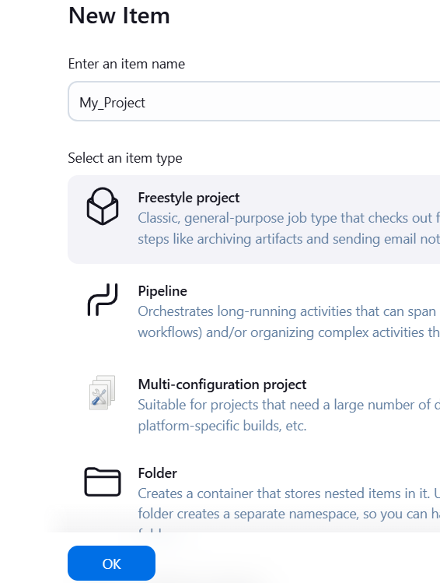

In the Project configuration page, add description

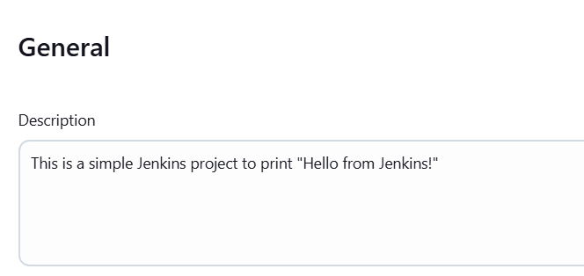

Scroll down to build section, add build step and execute shell. Add the following command in the shell box. And click save.

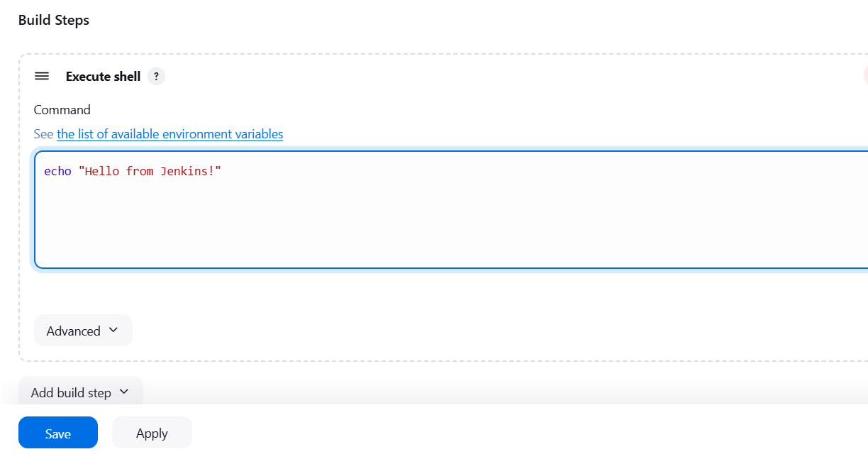

In the project dashboard, click build now.

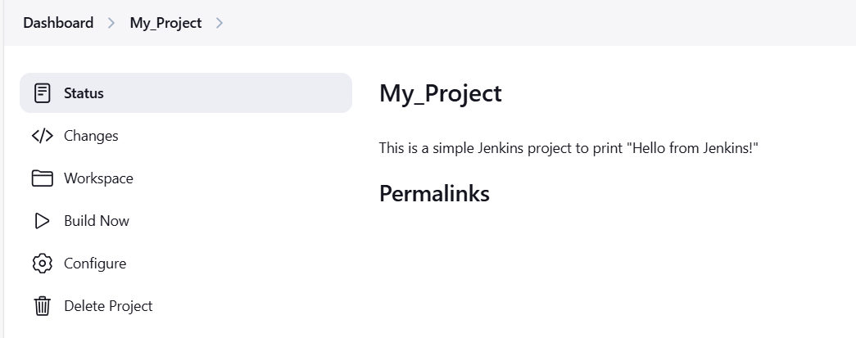

1. In the build history, click on the build number and click console output.

The following page is displayed.

